

Migration Deployemnt In INSIS Database
All version of Oracle Database

Project



DISCLAIMER

This document is strictly private, confidential and personal to its recipients and should not be copied, distributed or reproduced in whole or in part, nor passed to any third party.

Version history
Date | Version | Description | Author
2019-11-12 | 2.0 | Reviewed | Manoj Kumar Nunna

Contents
Version history 3
1. Introduction 5
2. Background info 5
3. Sanity check before migration code deployment. 5
4. Migration deployment after sanity check. 9

Introduction

This document will describe the process of migration deployment and pre-setup in INSIS database before running the migration code.

Background info

Migration code will create the below things in INSIS database.
- Migration Schema and objects under this schema
- Archival schema.
- Tablespace INSIS_MIGR_LF in DATA disk group.
- Temporary tablespace TEMPMIG01 in DATA disk group.

Sanity check before migration code deployment.

- Make sure that at least 65GB free space available in DATA diskgroup as both the tablespaces INSIS_MIGR_LF & TEMPMIG01 will be created in DATA diskgroup as per the below migration code.
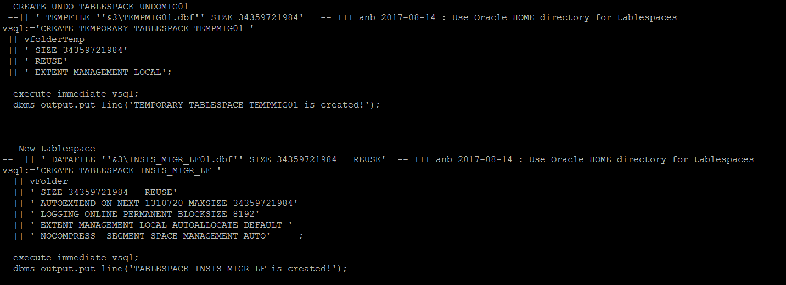

3.2. User Loading: load all the bolag user in INSIS database. Business/ Migration team can help with the bolag user.
After deployment table INSIS_MIGRATION_LF.ETL_BOLAG_INFO will have bolag wise username.Below snap taken from the database INSIS02@10.200.37.163
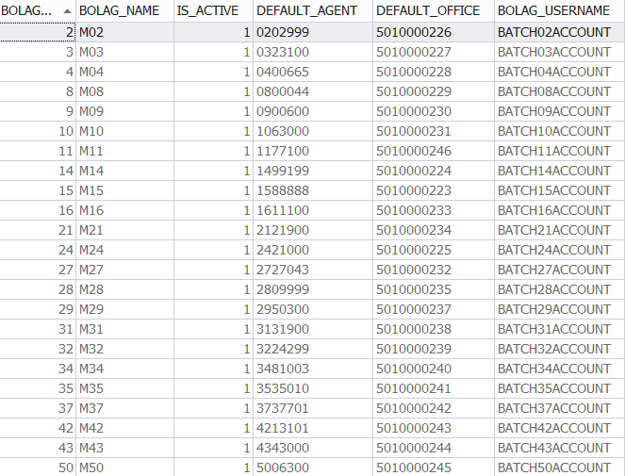

These users will be used during the migration run. So load them into the INSIS database before running the Migration deployment.

- Insert the user details in DB_CREATEINSISUSERS table.

- Run the below attached script. It will create the entities and restrictions that are marked with status 0, rest records will get ignored. Upon successful execution, all processed records will be updated with status from
0 to 1
- Upon loading the user successfully. Verify using below sql query.

SELECT users.USER_NAME, query_1.OFFICE_ID, query_1.OFFICE_NO, users.COUNTRY, users.ACCOUNT_ID, users.USER_EMAIL, users.LANGUAGE Office_Lang, query_1.LANGUAGE Staff_Lang, users.LOCK_ACCOUNT FROM INSIS_PEOPLE_V10.P_USER_ACCOUNTS users
JOIN (SELECT offices.OFFICE_NO, staff.OFFICE_ID, staff.ACCOUNT_ID, staff.Language
FROM INSIS_PEOPLE_V10.P_STAFF staff
RIGHT JOIN INSIS_PEOPLE_V10.P_OFFICES offices
ON staff.OFFICE_ID = offices.OFFICE_ID) query_1
ON users.ACCOUNT_ID = query_1.ACCOUNT_ID
AND users.USER_NAME IN ('BATCH02ACCOUNT','BATCH03ACCOUNT','BATCH04ACCOUNT','BATCH08ACCOUNT','BATCH09ACCOUNT','BATCH10ACCOUNT','BATCH11ACCOUNT','BATCH14ACCOUNT','BATCH15ACCOUNT','BATCH16ACCOUNT','BATCH21ACCOUNT','BATCH24ACCOUNT','BATCH27ACCOUNT','BATCH28ACCOUNT','BATCH29ACCOUNT','BATCH31ACCOUNT','BATCH32ACCOUNT','BATCH34ACCOUNT','BATCH35ACCOUNT','BATCH37ACCOUNT','BATCH42ACCOUNT','BATCH43ACCOUNT','BATCH50ACCOUNT');

Output will be like:
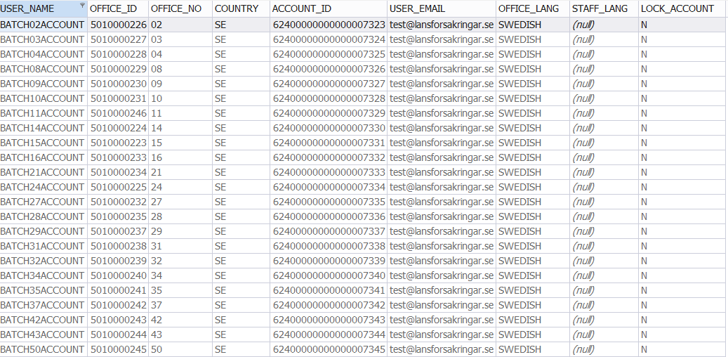

3.3. Change MAX_QUAL_LEVEL in table INSIS_PEOPLE_V10.P_STAFF for boalg user.
- Select MAX_QUAL level of user using below query.
SELECT pua.USER_NAME,ps.MAX_QUAL_LEVEL FROM INSIS_PEOPLE_V10.P_STAFF ps,INSIS_PEOPLE_V10.P_USER_ACCOUNTS pua
where ps.ACCOUNT_ID = pua.ACCOUNT_ID
and pua.USER_Name in ('BATCH02ACCOUNT','BATCH03ACCOUNT','BATCH04ACCOUNT','BATCH08ACCOUNT','BATCH09ACCOUNT','BATCH10ACCOUNT','BATCH11ACCOUNT','BATCH14ACCOUNT','BATCH15ACCOUNT','BATCH16ACCOUNT','BATCH21ACCOUNT','BATCH24ACCOUNT','BATCH27ACCOUNT','BATCH28ACCOUNT','BATCH29ACCOUNT','BATCH31ACCOUNT','BATCH32ACCOUNT','BATCH34ACCOUNT','BATCH35ACCOUNT','BATCH37ACCOUNT','BATCH42ACCOUNT','BATCH43ACCOUNT','BATCH50ACCOUNT');
- If MAX_QUAL_LEVEL is not 100 for bolag users then change using below query. As migration code will extract the USER_NAME from INSIS database where MAX_QUAL_LEVEL=100.

update INSIS_PEOPLE_V10.P_STAFF set MAX_QUAL_LEVEL=100
where ACCOUNT_ID in
(
SELECT ps.ACCOUNT_ID FROM INSIS_PEOPLE_V10.P_STAFF ps, INSIS_PEOPLE_V10.P_USER_ACCOUNTS pua
WHERE ps.ACCOUNT_ID = pua.ACCOUNT_ID
and pua.USER_NAME IN
('BATCH02ACCOUNT','BATCH03ACCOUNT','BATCH04ACCOUNT','BATCH08ACCOUNT','BATCH09ACCOUNT','BATCH10ACCOUNT','BATCH11ACCOUNT','BATCH14ACCOUNT','BATCH15ACCOUNT','BATCH16ACCOUNT','BATCH21ACCOUNT','BATCH24ACCOUNT','BATCH27ACCOUNT','BATCH28ACCOUNT','BATCH29ACCOUNT','BATCH31ACCOUNT','BATCH32ACCOUNT','BATCH34ACCOUNT','BATCH35ACCOUNT','BATCH37ACCOUNT','BATCH42ACCOUNT','BATCH43ACCOUNT','BATCH50ACCOUNT'))

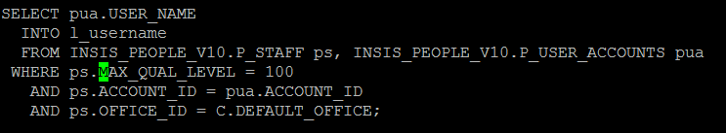

Migration deployment after sanity check.

- Deploy the migration code according to below Read_Me.

END OF DOCUMENT

